Single Factor ANOVAs

1. Single factor experiments
   1. Definitions
      1. Factor –
      2. Levels (treatments/treatment levels) –
   2. Example
2. Variability and the Sum of Squares
   1. Examples
      1. Two conditions: Right handed words, left handed words
      2. Here’s the data (attached excel).
   2. Histograms –
      1. X axis =
      2. Y axis =
      3. Histograms show you:
         1. HOW TO SPSS HERE

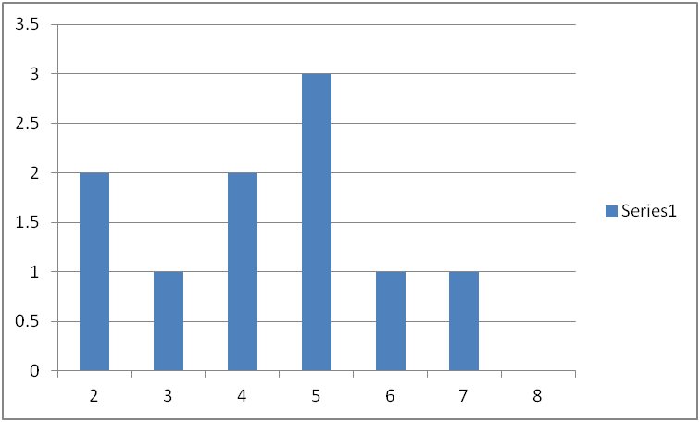

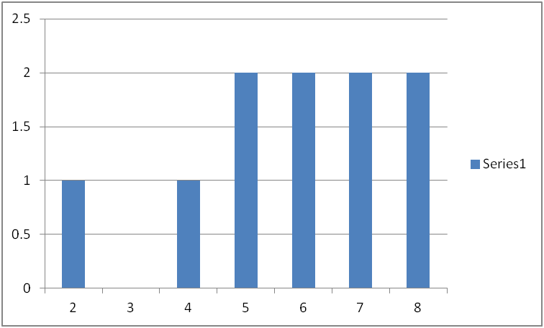

* 1. Distributional statistics
     1. Median –
     2. Mean –
        1. HOW TO SPSS HERE.
     3. So can I say that people prefer left handed words?

1. Hypothesis testing
   1. Descriptive
   2. Inferential
   3. Definitions:
      1. Samples
      2. Population
      3. Statistics
      4. Parameters
   4. Statistical Hypotheses
      1. Research hypothesis
      2. Statistical hypotheses
      3. Null hypothesis – H0
         1. H0
      4. Alternative hypothesis
         1. Ha
      5. Why would we test the null and not what we actually want to find?
   5. Experimental error
      1. Experimental error/error variability/error variance
      2. Potential causes of scores
         1. Permanent or stable abilities
         2. Treatment effect
         3. Internal variability
         4. External variability
   6. Evaluation of the null
2. Component deviations
   1. How do we actually measure treatment effects (between groups) and error (within groups) variance?
   2. We are going to add “equal words” to our experiment, so that you can see the calculations with three groups.
   3. Steps:
      1. Figure the means for all three groups
      2. Figure the grand mean:
      3. DRAW THE PICTURE.
      4. MAKE THE CHART

|  |  |  |  |  |
| --- | --- | --- | --- | --- |
| Score | Value | Total | Between | Within |
| Each persons score |  | Individual score minus grade mean | Group average minus grand mean | Individual score minus group mean |
| RIGHT 1 | 5 | -.83 | -1.53 | 0.7 |
| RIGHT 2 | 4 | -1.83 | -1.53 | -.3 |
| Etc. |  |  |  |  |

* 1. Between –
  2. Within –

1. Sum of squares – defining formulas
   1. Variances
   2. Variance
      1. Why squared?
      2. Variance =
      3. Sum of squared deviations = SS
      4. DF =
      5. Deviations =
   3. SS total
   4. SS between
   5. SS within
2. Computational formulas
   1. Treatment sums (group totals)
   2. Treatment means (group averages)
   3. Grand sum
   4. Grand average
   5. Bracket terms
      1. [] – steps
      2. [Y] =
      3. [A] =
      4. [T] =
   6. Therefore
      1. SST =
      2. SSbetween =
      3. SSwithin =